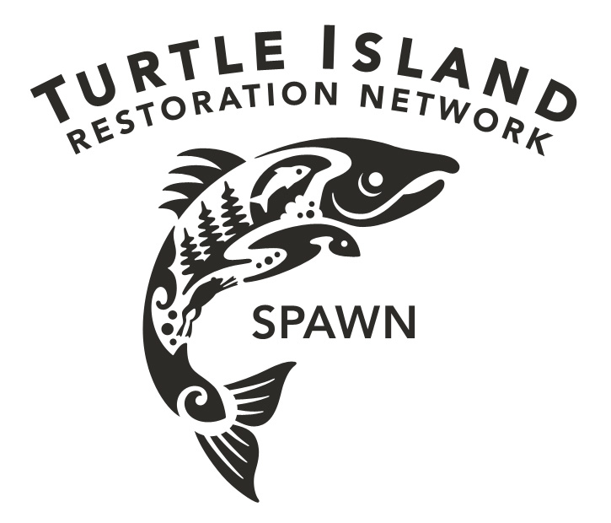
#SAVEMARINSCOHO
Marin Supervisors,
Take Action Now!
I Demand Coho Protection …

