Turtle Island Restoration Network Cocos Island Research Expedition

Dive Researcher Profile Form
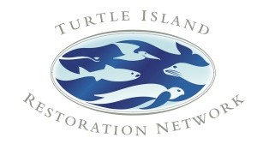
We're excited to welcome you on board our Cocos Island Diving Expedition. Please note that rules have recently changed at Cocos Island, and we must ask for complete information about your experience in order to ensure the greatest participation in our research project. Please detail any dive, professional or academic experience related to our sea turtle and shark tagging research project. You can fill the form out digitally, scan and email it to info@tirn.net or fax to 415-663-9534. Thank you!

First Name: Last Name: Email: Street: Street 2: City:
State/Province: Zip/Postal Code: Country: Preferred Phone:

Personal:

How did you hear about our Cocos Island dive trips? What is your birthday?
Do you have any special dietary needs?

Do you know anyone else who might be interested in a trip? Include email so we can send them information:

Is there anything else we should know about you?

Diving, Professional and Academic Experience

Dive certifications you hold:

Please summarize your diving experience, including number of dives and hours if possible:

Can you use a spear gun or Hawaiian sling? What is your academic background?
What is your profession?

Have you ever participated in a biological research project (diving or otherwise) or any other research effort?

Do you have any skills related to technical equipment?

Do you have experience in any setting with Excel spreadsheets, data input or statistical analysis?

Do you have a medical background?

Describe any experience you have with environmental projects and organizations, or other community service:

Thank you for providing this information. Please email us at info@seaturtles.org if you have any questions about the expedition or your registration.

