COHO SPAWNING TRENDS IN LAGUNITAS CREEK, MARIN COUNTY
This graph includes coho spawning redd (nest) data collected in Lagunitas Creek from 1995 through 2019. Each point on the graph represents the 3-year geometric mean (annual average number of redds recorded for three consecutive annual cohorts). Using the geometric mean gives an estimate of the total population of this species because coho salmon have a rigid three-year birth to death life cycle. The 2019-20 count to date is 46 (black square), but is anticipated to increase slightly before the spawning season ends to approximately 50 redds.
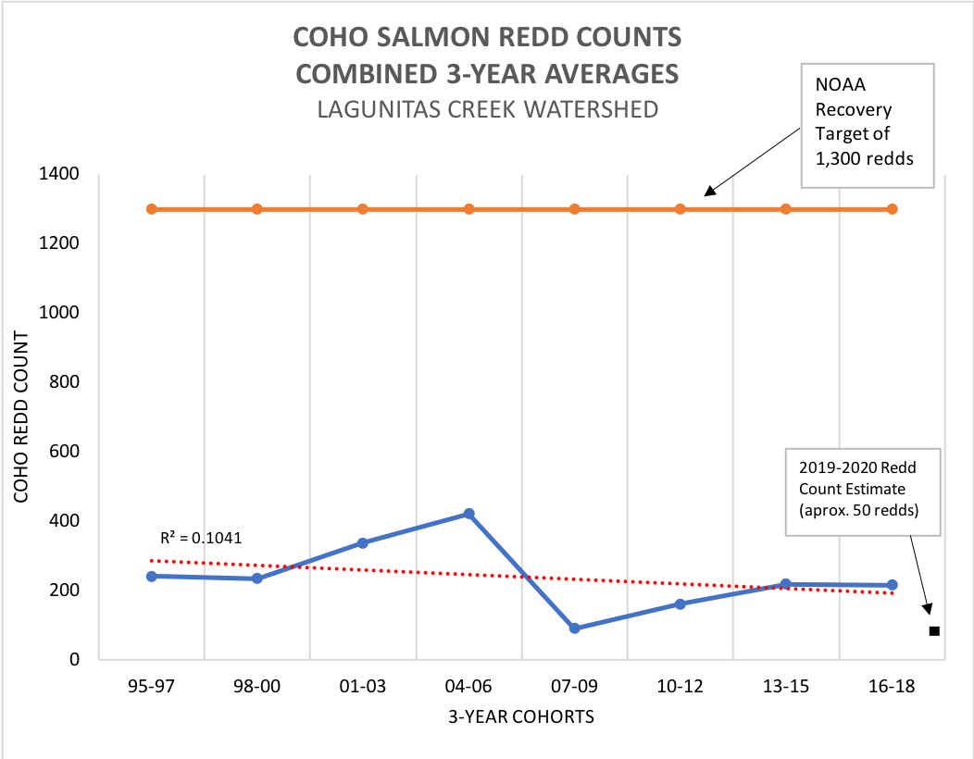

Data from report: E. Etlinger and G. Guaiumi. January 2019. Adult salmonid monitoring in the Lagunitas Creek Watershed 2017-18. Marin Municipal Water District, in association with the National Park Service, Point Reyes National Seashore and the Salmon Protection and Watershed Network (SPAWN).

