Substrate Classification, Embeddedness, and Scour Chain Surveys of Known Coho Spawning Habitat along Lagunitas Creek
Study carried out by SPAWN of Turtle Island Restoration Network
Research article authored by Preston Brown and Bryce King
Introduction
Coho salmon are known to form redds just upstream of riffle crests and prefer substrate that ranges from the size of a golf ball (1.5in) to the size of a fist (5in). Salmon Protection and Watershed Network (SPAWN) will be surveying riffle crests and pool tailouts along Lagunitas Creek that meet those minimum requirements in an effort to understand the current quality of spawning habitat for the Coho, how that habitat is impacted by the completion of our project at what used to be the town of Jewell, and how that habitat is affected by winter storm events.
Table 1
Classification | code | Particle Diameter (in) | Particle Diameter (mm)
bedrock | 9
Boulder (large) | 8 | > 24 | > 610
Boulder (small) | 7 | 12 - 23.9 | 305 – 609
cobble (large) | 6 | 9 - 11.9 | 228 – 304
Cobble (medium) | 5 | 6 – 8.9 | 152 - 227
Cobble (small) | 4 | 3 – 5.9 | 76 - 151
Gravel (Large) | 3 | 2 – 2.9 | 50 – 75
Gravel (Medium) | 2 | 1 – 1.9 | 25 - 49
gravel (small) | 1 | .2 - .9 | 5.1 - 24
Fines | 0 | < .19 | < 5

Embeddedness
Stream embeddedness measures the percent of gravel, cobble, and boulders that are entombed in fine sediment. As denoted in Table 1, golf ball and fist size substrate fall into the gravel and cobble categories. Embeddedness is directly related to the amount of habitat there is available for benthic macroinvertebrates (BMI’s are an important salmonid food source) as well as the conditions necessary for various fish species to spawn. Fine sediment can plug up interstitial space overcrowding BMIs and suffocating salmonid eggs after they have been laid. According to Punuske Chatham Inc’s Lagunitas Creek impact assessment, embeddedness levels below 25% were ideal for Coho habitat, levels between 25% and 50% were okay, and levels >50% were severely detrimental to Coho egg survival rates.

For standardization purposes, SPAWN will use the modified Brusven Index (Brovee 1982) to express the largest substrate, dominant substrate, and embeddedness percentage in a 3-digit number. Table 1 lays out the single digit code associated with substrate sizes. In accordance with the Modified Brusven Index, the digit in the ten’s place represents the largest materials in the sample, the digit in the one’s place represents the most prevalent material surrounding the dominant particles, and the digit after the decimal represents the percent embeddedness rounded to the nearest tenth. For example, a sample consisting of small boulders surrounded by medium gravel with a 50% embeddedness would have a modified Brusven Index of 72.5. While the small boulders might be embedded in the medium gravel, we will only count embeddedness as the percentage of those larger particle sizes that are entombed by fines. Using the mBI helps assimilate data in such a way that mathematical process can be used to create empirically backed models. It can also be a great reference point to quickly compare data with other studies about riparian habitat for salmonids.

Scour Chains
While it is known that winter habitat is the limiting factor for Coho and other salmonid survival, it is not thoroughly understood which aspect of winter has the greatest impact on survival rates. Lack of winter refugia for juveniles, redd scour or redd embeddedness all have compounding effects on salmonids.
Scour chains can be used to understand the maximum level of scour over a period of time, say after a few large storms roll through. If a redd scours below the level at which salmonids laid their eggs, then it can be assumed that almost all the eggs were washed downstream and survival rate along that reach will be nearly zero. Scour chains are literal chains or strong cord buried or inserted vertically into a streambed so that one end extends below the depth of anticipated maximum scour and the other end drapes over the bed surface. The free end of the chain stays on the surface as the bed scours and is buried as the bed fills. The final level of the horizontal section of chain indicates maximum scour depth.
To record the level of scour, surveyors must typically excavate each time. However, an alternative method using floating beads as indicators will enable surveyors to check scour depth without a complete excavation. The aforementioned strong cord is strung with floating beads of a known length and the cord is buried vertically up to the top of the first bead with excess cord attached to a buoy floating on the surface or in the water column. As the bed scours, beads will be released from the substrate and move up the cord to bob with the buoy. As the bed fills, the cord will be reburied at an angle, but the beads will remain floating near the surface. A surveyor will be able to quickly pass through and record maximum levels of scour by counting the released beads and multiplying by the known length with little to no excavation. An illustration is provided on the next page from a study we closely emulated.
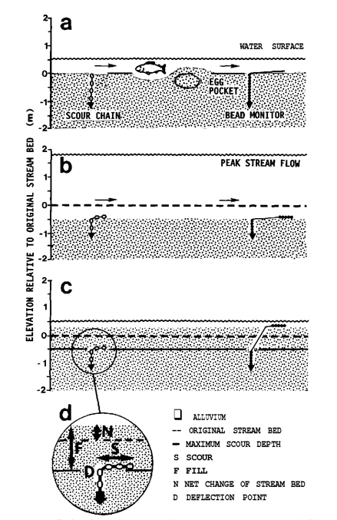

Our floodplain expansion project at Site 2 creates off-stream habitat that will provide more opportunities for fry and smolts to shelter during large flow periods. We expect the side channels to decrease the intensity of flow across redds within the main stem especially where the redds and side channels connect. SPAWN will be placing scour chains near those confluences to understand how our project affects the spawning habitat value of the Coho. We will also place scour chains along redds without confluences to broaden our perspective and provide a baseline to compare our results. The scour chain controls will be placed along redds within our project area as well as along redds upstream and outside of our project area. It should be noted that while scour chains do illuminate maximum scour, they do not provide a temporally accurate account of scour and fill events between data collection periods because stream beds are constantly changing. Ongoing surveys about substrate classification, stream embeddedness, and maximum scour will enable SPAWN to access the current state of Coho spawning habitat, how our projects affect that habitat, and illuminate another factor that plays into winter salmonid survival rates.

Methods
Embeddedness
Cross sections were created at the same riffle crests as the scour chains. If the bead monitors did not create a line perpendicular to channel flow, then a cross section between the two bead monitors was chosen. SPAWN walked the length of these cross sections and laid a 1 foot by 1 foot pvc square down every couple of feet keeping to the center of the transect. Substrate sizes within the grid were approximated and encoded using the Brusven Index denoted by Table 1. The embeddedness was measured by picking up individual pieces of gravel or cobble using your fingers to mark the level at which fines surrounded the substrate. The percent embeddedness was then estimated by the amount of substrate that was buried by the fines. Five to eight gravel and cobble pieces were chosen for each sample square and the percent embeddedness was averaged and then rounded to the nearest 10 percent. This process was then repeated for every cross section along each redd to get an accurate picture of the substrate classification and embeddedness to inform current spawning habitat value. The foot by foot grid is tough to handle underwater so once surveyors are skilled at estimating the sample size, these steps can be repeated quickly and accurately without it.
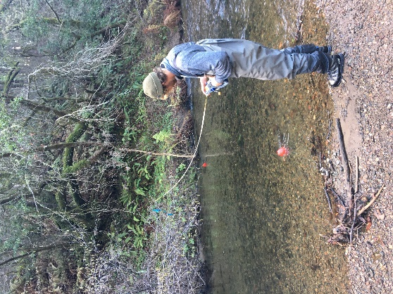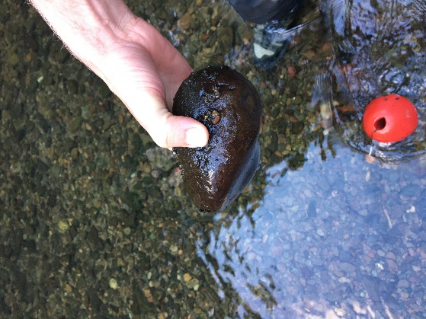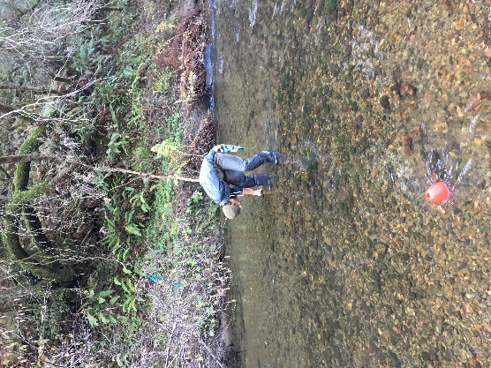
Scour Bead Monitors
10 scour chains were constructed using braided steel cable, 1” beads cut from a wooden dowel, repurposed plastic T-post identifiers, buoys, cable stoppers, a metal pipe, a rebar stake, a T-post pounder, wire cutters, thin-nosed pliers, a sledge hammer, rubber bands, bolts, nuts, protective eyewear and earmuffs. We placed 2 chains at riffles of interest within site boundaries and 1 scour chain outside the project areas to have control values of scour in the main stem. Our methods emulated a study enacted by the Siskiyou Regional Education Project and Dept. of Fisheries and Wildlife.
The T-post identifiers were cut with a chop saw into a blunted light-bulb shape before having holes for the bolts drilled through their hollow ends. They slid in the pipe while the light-bulb ends stayed outside.
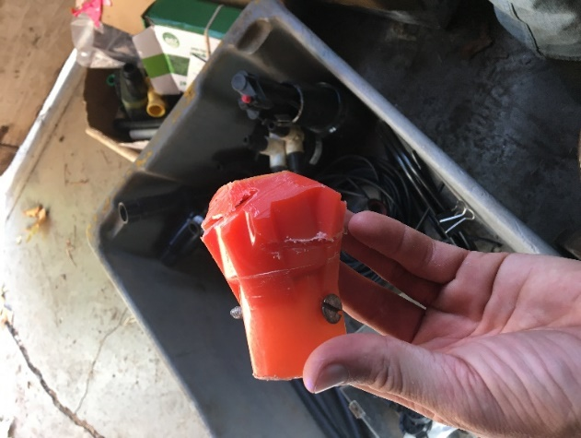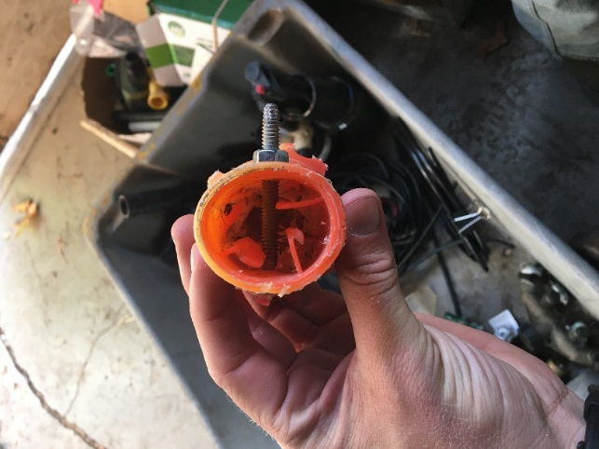
The bolts along with the nuts were attached as cross beams and the braided steel cable was then tied onto the bolt. We used 5-5.5 ft of cable per scour chain but I would recommend using 6-6.5 ft to give yourself extra room. Cable stoppers might be easier to use if you don’t know or don’t want to struggle making strong knots. Super glue was used to ensure that the nuts didn’t come off the bolts. Make sure to get bolts that fit inside the pipe!
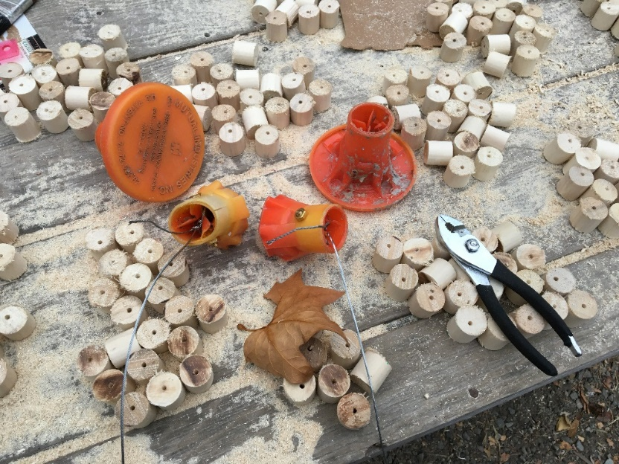
The dowels were cut into 1 inch beads and a hole was drilled in each bead in order to thread the cable.
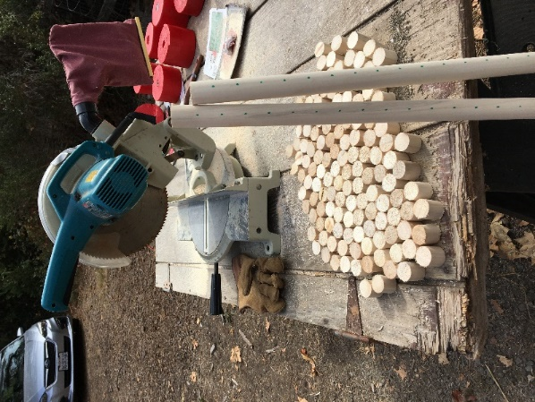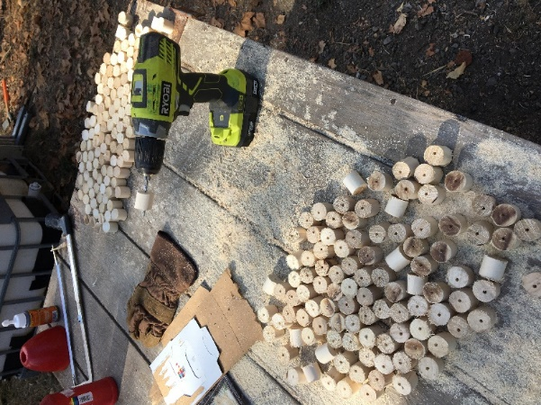
Decide which end of the pipe you will be pounding and which end will go into the ground. Rest the T-post pounder on the pounding end of the pipe and drill a hole in the pipe a few inches below the bottom of the pounder. You will be threading the cable of your scour chain through this hole and will need to hold the wire taught while a partner uses the T-post pounder to embed the scour chain.
The buoys were painted and all these raw materials were brought to the site separately. In the photos below, the buoys were attached preemptively and had to be removed prior to installation.
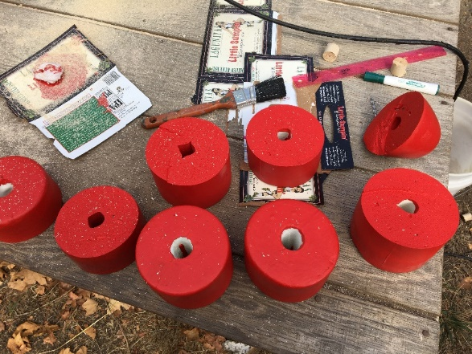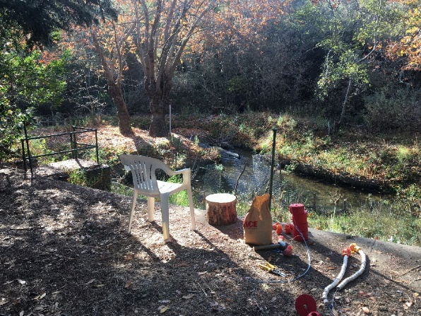
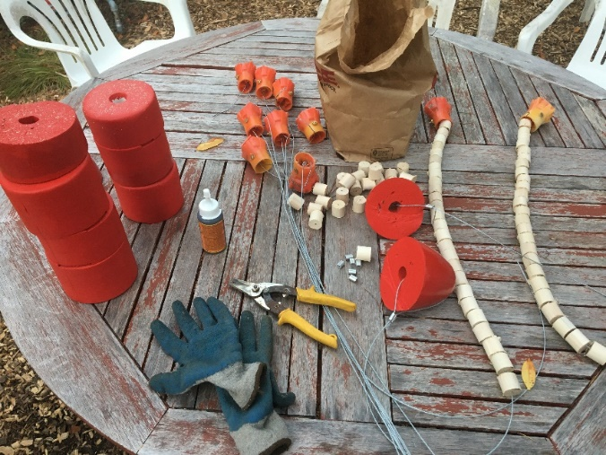
Installation provided a lot of extra difficulties, but as we gained more experience and changed our methods we were eventually able to get installation time down from 1.5 hrs to 1 per 15 mins.
Start by wrapping the rubber bands around the cable in order to hold the beads compactly against the T-post indicator. You need all of the beads to be touching so that you know the depth of scour when they are released from the substrate. Thread the loose end of cable through the pipe so that it comes out of the hole you drilled and that the T-post indicator is flush against the end of the pipe that will go into the ground. Mark the outside of the pipe at a height level with the top of the beads using a sharpie. Put on waders in order to enter the creek and decide exactly where you want the scour chain. Have 1 person ensure the pipe remains vertical and hold the cable taught so that the T-post indicator is flush with the pipe while the other person uses the T-post pounder to bury the scour chain. Make sure to wear protective equipment (especially earmuffs!).
Once the pipe is buried and the sharpie line you drew is level with the undisturbed substrate, remove the T-post pounder and get the rebar. Insert the rebar all the way down the pipe making sure that the rebar connects with the T-post indicator at the bottom. Have one person hammer the rebar to separate the T-post indicator from the pipe while the other person twists and pulls the pipe out of the ground. Once the pipe is out, feel free to remove the rebar as well. If you did things correctly, then the rubber band holding the beads in place should be level with the undisturbed substrate (if a pit was created, fill it in until level with the streambed).
Thread a cable stopper and buoy onto the cable and then pull the cable around the buoy and back through the cable stopper. Try to leave > 2 ft between the cable stopper and the rubber band so that the beads have room to float when scour occurs. Use pliers to hold the cable stopper, a hammer, and a hard surface (we had bricks) to squish the cable stoppers so that they hold the buoys. Wire cutters were necessary to clean up the cable ends so that they would go through the cable stoppers and the pliers were used to bend the remaining cable sticking out of the cable stoppers out of the way. Make sure that the cables aren’t kinked and that it would be easy for a released bead to float all the way to the buoy.
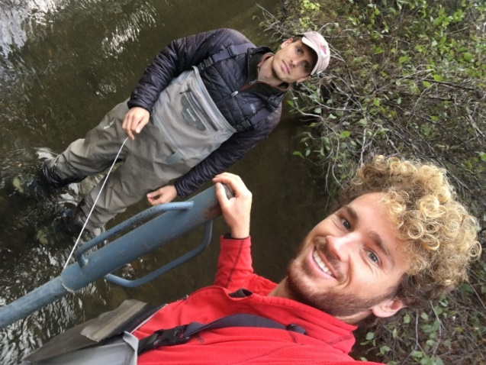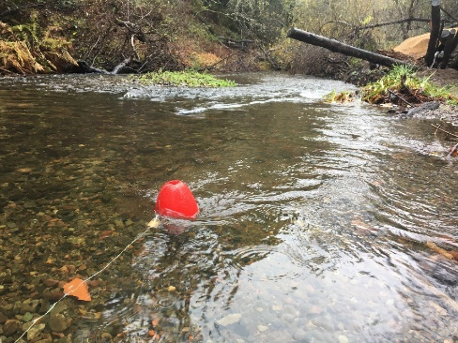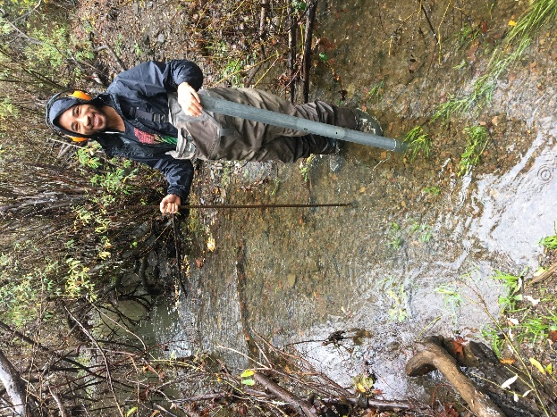
The middle photo above is what our scour chains looked like when completed. That floating was accidentally released during installation, but it is reassuring to see the bead monitors work!
Potential Problems
Three general problems are involved in interpreting some observations of scour and fill. The first problem is whether or not an average position of the streambed at a cross section can satisfactorily be based on a few observations at the section. By placing scour chains at intervals less than 8 ft apart we have mitigated this representational error.
The second problem is whether or not an average bed position at a cross section can be determined from observations of maximum instantaneous depths of scour. In this study, we have not drawn conclusions about the average bed position. Maximum level of scour was compared to typical redd depths to understand if salmonid eggs were likely to be washed downstream. Transects will be first placed in riffles where redds will most likely be located, however over time the position of the riffle crest may change or be displaced. So the sour chains and streambed monitoring would need to chase the riffles as they migrate across the stream over the years.
The third problem is whether or not average or typical changes in elevation of the sand bed in a stream reach can be determined from observed changes in average position of the streambed at one or a few cross sections. Since these cross sections do not exist in isolation, we can mitigate this error in assumption by understanding individual cross-sectional behavior in the context of the stream system. The fact that scour chains will be placed at confluences as well as controls will provide us with insight as to how our constructed habitat is affecting typical stream behavior.

Data Collected
Collected data has been entered into a running Google Spreadsheet. A printable version of the data sheet is shown on the next two pages.
Conclusions Drawn
Conclusions will be drawn once sufficient evidence has been collected.

Classification | code | Particle Diameter (in) | Particle Diameter (mm)
bedrock | 9
Boulder (large) | 8 | > 24 | > 610
Boulder (small) | 7 | 12 - 23.9 | 305 – 609
cobble (large) | 6 | 9 - 11.9 | 228 – 304
Cobble (medium) | 5 | 6 – 8.9 | 152 - 227
Cobble (small) | 4 | 3 – 5.9 | 76 - 151
Gravel (Large) | 3 | 2 – 2.9 | 50 – 75
Gravel (Medium) | 2 | 1 – 1.9 | 25 - 49
gravel (small) | 1 | .2 - .9 | 5.1 - 24
Fines | 0 | < .19 | < 5
Brusven Code:
The digit in the ten’s place represents the largest materials in the sample, the digit in the one’s place represents the most prevalent material surrounding the dominant particles, and the digit after the decimal represents the percent embeddedness rounded to the nearest tenth.
Cross-section  (moving upstream) | Wetted Channel Width (ft) | Height to Floodplain (ft) | Number of sample squares (1 ft²) | Brusven Indices
1

2

3
(control)
4
5
6
(control)

Scour Bead Monitors  (moving upstream  L R) | Wetted Channel Width (ft) | Height to Floodplain (ft) | Number of Floating Beads (in) | Peak Flow Since Last Survey (cfs)
1
2
3
4
5
(control)
6
7
8
9
10
(control)
ADDITIONAL COMMENTS:

Slezak, Ryan. “2008 Mainstem Klamath River Coho Spawning Survey.” USFW, Arcata Fish and Wildlife, 2009.
“Trinity River Flow Evaluation.” pg 25. USFW, Fish and Wildlife Enhancement Sacramento Field Office, 1989.
“San Geronimo Valley Salmon Enhancement Plan.” Prunuske Chatham Inc. & Stillwater Services, 2010.
“Mitigation Options for Fish and Wildlife Resources Affected by Port and Other Water-Dependent Developments in Tampa Bay, Florida.” pg 25. Continental Shelf Associates Inc., 1986.
“Lagunitas Limiting Factors Analysis.” Stillwater Sciences, 2008.
“Measuring Scour and Fill of Gravel Streambeds with Scour Chains and Sliding-Bead Monitors.” Siskiyou Regional Education Project and Dept. of Fisheries and Wildlife, 1993.
Colby, Bruce. “Scour and Fill in Sand-Bed Streams.” US Department of the Interior - Geological Survey, 1964.

